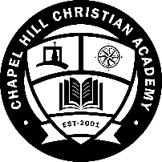
Chapel Hill Christian Academy
Student Enrollment Application
**PLEASE ALLOW A MINIMUM OF 4 WEEKS FOR THE ENROLLMENT PROCESS**

*Registration fees apply per student and are as follows:
Prior to June 1^{st:}: $25/ per returning student $50/per new student application
June 1st-July 1st: $150/ per student new/returning

Students’ Full Name_________________________________________________________________
Last First Middle

Physical Address____________________________________________________________________

Mailing Address (if different) _________________________________________________________

Birthdate: Month___ Day___ Year___ Birthplace: ________________ Grade Entering_____

Please place a checkmark beside each phone number you would like to be used for the CHCA phone communication. (Limit 2 per family)

Home phone: __________ Father Cell ( )_______________ Mother Cell( )_______________

E-mail Address__________________________________________________________________________________

Date of Application______________________________

Local School District of Residency_________________________________________________________

Where does the applicant attend church? __________________________________________________

Pastor’s Name_____________________________

Church Address______________________________________

Is applicant a member of the above-mentioned church? Yes___ No___



Chapel Hill Christian Academy
Student Enrollment Application

How often does applicant attend church? 2x weekly___ Weekly ___ Monthly___

Has applicant made a profession of faith in Jesus Christ? Yes___ No___

If so, please give a brief testimony________________________________________________________

______________________________________________________________________________

Legal Guardian if other than Parent____________________________/Relation to Student____________

Father’s Name | Mother’s Name
Employer | Employer
Employer Address | Employer Address
Employer’s Phone | Employer Phone
Marital Status | Marital Status

Chapel Hill Christian Academy
Student Enrollment Application

Additional Children:

Child 2:

Full Name: ___________________________________________________________________________________

Birthdate: Month___ Day___ Year___ Birthplace: ________________ Grade Entering_____

-------------------------------------------------------------------------------------------------------------------

Child 3:

Full Name: ___________________________________________________________________________________

Birthdate: Month___ Day___ Year___ Birthplace: ________________ Grade Entering_____

--------------------------------------------------------------------------------------------------------------------

Child 4:

Full Name: ___________________________________________________________________________________

Birthdate: Month___ Day___ Year___ Birthplace: ________________ Grade Entering_____

--------------------------------------------------------------------------------------------------------------------

Child 5:

Full Name: ___________________________________________________________________________________

Birthdate: Month___ Day___ Year___ Birthplace: ________________ Grade Entering_____

Chapel Hill Christian Academy
FINANCIAL AGREEMENT

The tuition for Chapel Hill Christian Academy School (2022-2023) is as follows:

1 st Child - $225.00 per month
2 nd Child - $175.00 per month ($50 dollar discount)
3 rd Child - $125.00 per month ($100 dollar discount)
* There is no discount beyond three children.
** Tuition includes all required materials.

- I understand that the policy of CHCA is to make no refund of registration fees, book fees. Reimbursement for pre-paid tuition is done upon CHCA board approval.

- Payment is due by the 15th of every month (August-May). A late fee of $25 will be automatically charged if monthly payments are late.

a.) I understand that if my account is seriously delinquent, my child(ren) will not be permitted to attend classes until the account is satisfied.

b.) I understand that my account will be charged a $20.00 returned check fee or credit card charge back fee for each check returned or charge back on my account.

c.) I understand that there will be a financial hold on my child(ren)'s report card(s) if payment is not current at the end of each grading period. This financial hold will remain in effect until the account is current.

3. I understand that the entire amount of tuition must be paid whether the child is present in school or not. No exemption from payment of tuition will be made for sickness or any other cause that results in absenteeism, including expulsion, withdrawal, dismissal, or any other circumstance.

- I understand that I am ultimately responsible for all payments to this account.

I/we agree to abide by and adhere to the stipulations and limitations set forth in this policy by Chapel Hill Christian Academy.

_____________________________________________________________________________
Parent/Legal Guardian Signature Date

_____________________________________________________________________________________________
Parent/Legal Guardian Signature Date
Chapel Hill Christian Academy
Pastor’s Reference

Families applying for CHCA enrollment are requested to have a pastoral reference from their church. Please sign this form giving permission for release of information and submit to your pastor.

I hereby authorize release of information to the Chapel Hill Christian Academy, for the purpose of application for enrollment.

Signature of Parent/Guardian

Name of Church

Pastor’s Name

Church Phone

Church Address ___________________________________

_____________________________________

_____________________________________

*Please have your pastor fill out the attached form.

Chapel Hill Christian Academy
Pastor’s Reference

Dear Pastor,

Has applied to Chapel Hill Christian Academy. We see ourselves as functioning best when our efforts can be combined with the Christian influence of our student’s home and church. It will be a great help to us if you can give us your candid response to the following questions.

- Are the student’s parents active in your church?

- How long have you known the family?

- Do they demonstrate a consistent desire to raise their children to love and serve Jesus Christ?

- From your contact with them, would you expect them to be faithful in maintaining their financial commitments?

- Does the student have any special needs or demonstrate any special strengths that you are aware of?

- Are there any additional comments that you feel would be helpful for us to know about the family?

- How can we help your church in its ministry to this family?

Date Signed

Pastors, to preserve confidentiality please send this completed form directly to:

Chapel Hill Christian Academy
7530 Johnstown Road
Mount Vernon, Ohio 43050

Chapel Hill Christian Academy
Statement of Cooperation

- The administration has full responsibility for placing my child in the proper grade.
- The school reserves the right to dismiss any student who himself or whose parents do not respect its spiritual standards or cooperate in the educational process.
- We understand students are accepted on a conditional basis. If acceptable progress has not been shown by the end of the first grading period, the student shall be withdrawn from CHCA and placed in a program more designed to meet his/her needs. The teacher’s judgment shall be relied upon for the acceptability of student progress.
- We pledge our loyalty to the aims and ideals of CHCA and will bring any and all questions and criticisms directly to the administration so that they may be properly considered by those in authority.
- We have read the Statement of Faith and the school philosophy and are willing to have our child trained in accordance with them.
- It is my understanding that it is the school’s policy to make no refund on tuition paid in full and or registration fees.
- We give CHCA permission for our child to take part in all school activities, including field trips and school sponsored trips away from the school premises.
- We also believe that discipline is necessary for the welfare of each student as well as for the entire school. We give permission for our child’s teacher and/or other agent of the school to make and enforce classroom regulations in a manner consistent with Christian principles and discipline as set forth in the CHCA Handbook.
- This Statement of Cooperation will be in effect for as long as my children listed (or others to be enrolled) attend CHCA.
- We understand that should our martial status change that is our responsibility to have a corrected Statement of Cooperation signed, updated, and delivered to CHCA.
- We give our permission for our student(s) to be photographed and/or video-taped during various events throughout the day and/or school year for the use of the school, website, and promotional materials, etc.

OR

Please do not publish _____________________________________ (student name) in

the following resources: __________________________________________________

- We have read and understand the entire contents of the Parent-Student Handbook, and we are willing to abide by all the regulations stated therein.
- We have read the dress code regulations found the Parent-Student Handbook and agree to uphold and enforce uniform guidelines of our students

Chapel Hill Christian Academy
Statement of Cooperation

- We have read and are willing to abide by their principles and standards outlined in the Parent Student handbook. If we are disturbed by a policy or decision of the school, we will speak to the teacher first, then the supervisor and, finally, to the school board/church deacons, rather than to other parents. If we cannot continue our support of the school, we will withdraw our child without seeking to discredit the ministry or its personnel.

Signature of parents:

_________________________________ ____________________________________
Father Mother

_________________________________ ____________________________________
Sole Guardian Date

Chapel Hill Christian Academy
Standards of Conduct

The goal of a Christian should be a life consecrated to God and separate from the world. CHCA commits to providing an environment conducive to spiritual growth and development in order to help young people meet this goal. A standard of conduct, based on the following Biblical imperatives, is necessary to provide such an environment. All the activities of the Christian must be subordinated to the glory of God who indwells us (1 Corinthians 8:9, 12, 13, 10:32). The Christian will endeavor to avoid practices which cause the loss of sensitivity of the spiritual needs of the world and loss of the Christian’s physical, mental, or spirit well-being (1 Corinthians 9:27).

A sense of the need for spiritual growth in the light of these principles has led CHCA to adopt the following standards that are conducive to the environment that will best promote the spiritual welfare of the student. The school, therefore, request each student, whether at home, school, or elsewhere to:

- Refrain from swearing, using indecent language, smoking, drinking alcoholic beverages, abusing drugs, gambling, and or sexual immorality.
- Maintain Christian standards in courtesy, kindness, morality, and honesty.
- Show respect to God, country, family, school, faculty, and fellow students.

The selection of the restrictions mentioned in this pledge may appear arbitrary to some; but while not condemning others who see differently, CHCA believes that the restriction names the types of conduct that are necessary for maintaining a Christian atmosphere of learning and development.

In this atmosphere of definite and positive Christian standards of conduct, good scholastic planning, and personal interest between faculty and student, there is fine opportunity for development of strong Christian character.

I have read the Standards of Conduct and agree to fully cooperate with these standards. I understand that anyone who will not cooperate spiritually, morally, or scholastically will be dismissed.

__________________________ __________________________ ____________________
Student’s Name & Grade Level Student’s Signature Date

As a parent I have read the standards of conduct. I will cooperate with the school in its endeavor to maintain these high Christian standards.

____________________________________________
Parent’s Signature

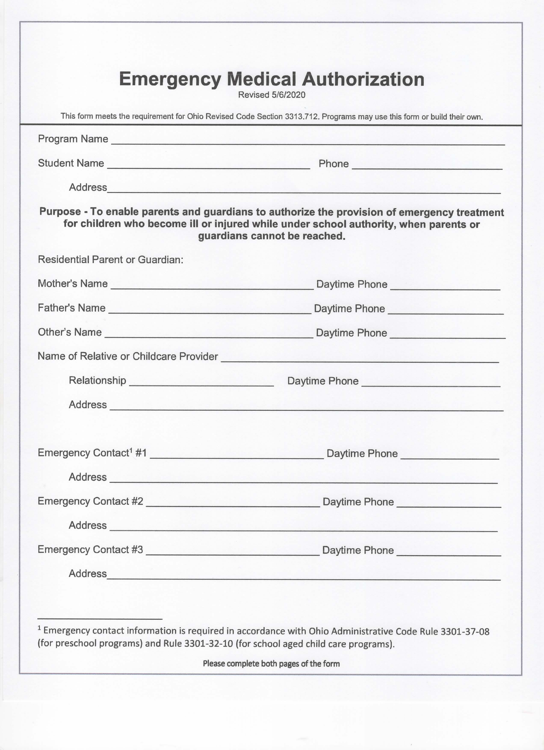

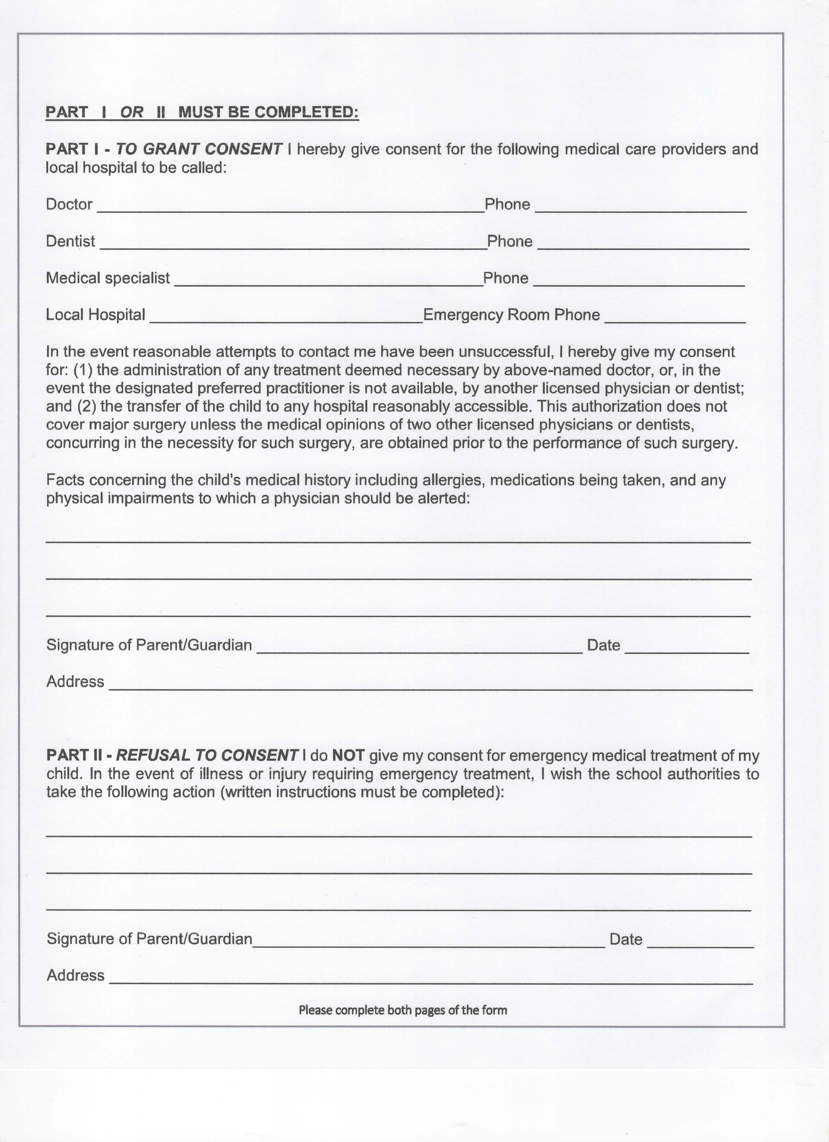

For Office Use Only:

Family Name ___________________________________________

To Be Completed by Office Personnel Only

School Year Applied For: ___________________________

Admittance Process- Steps Completed

___1 /Date__________

___2 /Date__________

___3 /Date__________

___4 /Date__________

___5 /Date__________

Date Accepted: __________ Date Denied: __________

Reason for denial if applicable_________________________________________________________________
_____________________________________________________________________________________________

_____________________________________________________________________________________________

